Head instructors please contact GM Plichta for your cost on all items. NOTE: Shipping and handling is extra. Currently coffee mugs and shot glasses are only available for local pick up in PA. due to the cost to ship is more expensive than the item.

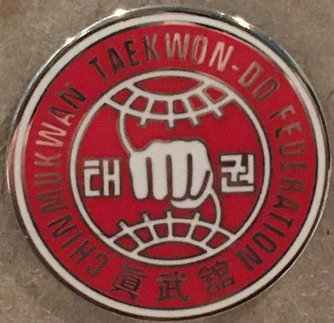CTF Student Pin 1”

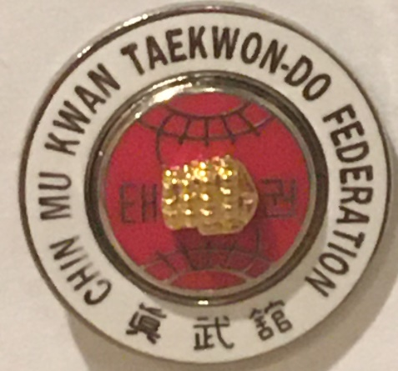CTF Black Belt pin 3 Tier 1”

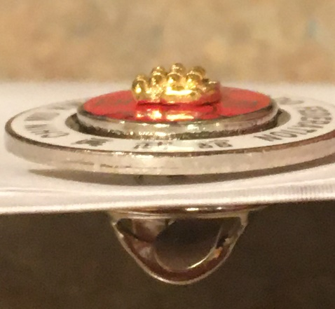

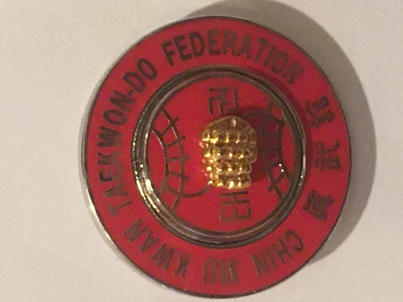 CTF Master Pin 3 Tier 1”

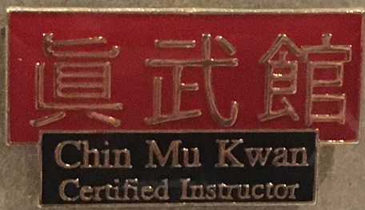CTF Certified Instructor pin 1”

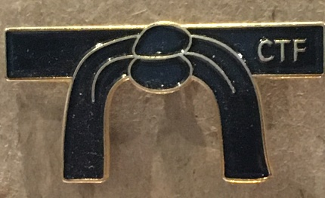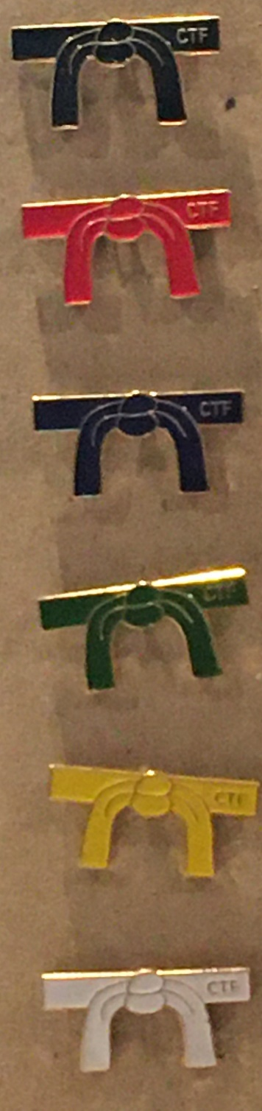CTF Belt Pins 1 1/4”

Detail

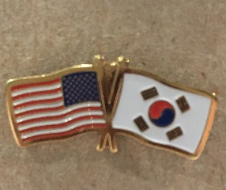United States-South Korean Flags 1”

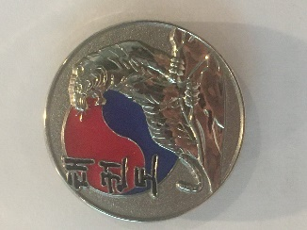Taekwon-Do Tiger 1”

Made for the GGM who loved tigers

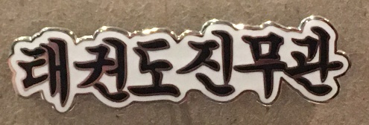

Taekwon-Do Chin Mu Kwan 1 ¼”

In Korean, TKD is always first, followed by the Kwan name as per the GGM

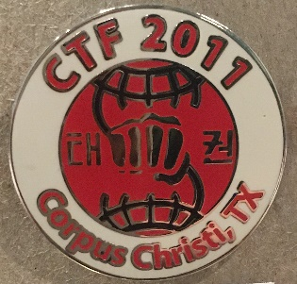

CTF 2011 Corpus Christie Nationals Pin 1”

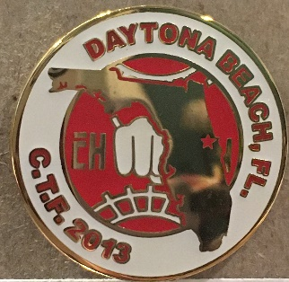

CTF 2013 Daytona Beach, Fl. Nationals pin 1”

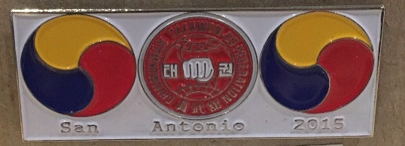

CTF 2015 San Antonio Tx. Nationals Pin 1 ¾

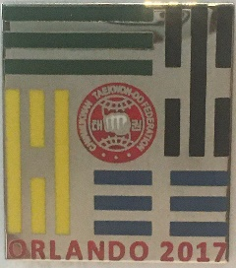

CTF 2017 Orlando Fl. Nationals pin 1”

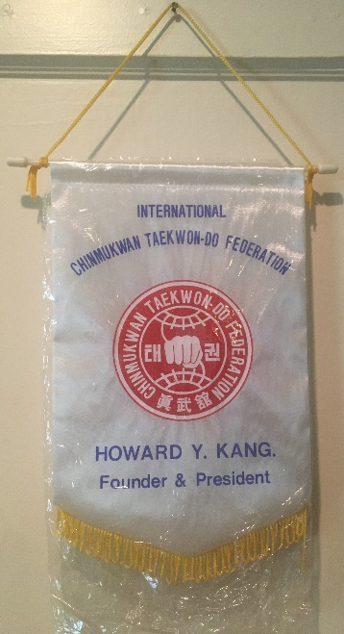Traditional CTF Presentation Banner 12’ x 9 ½ “

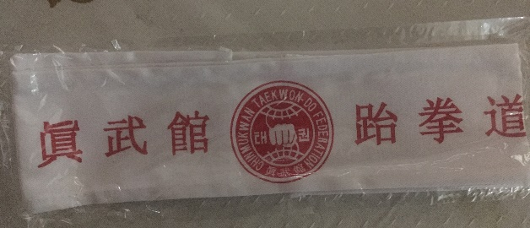

CTF TKD Head Band

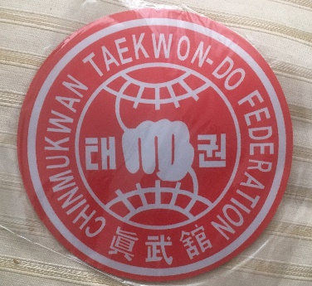

CTF Mouse Pad 8”

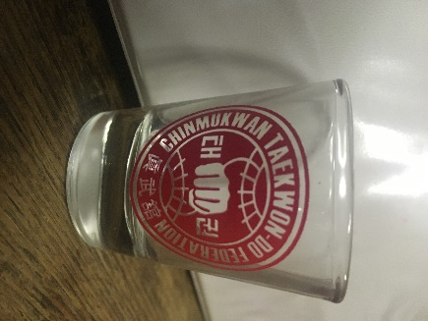

CTF Shot Glasses Limited supply

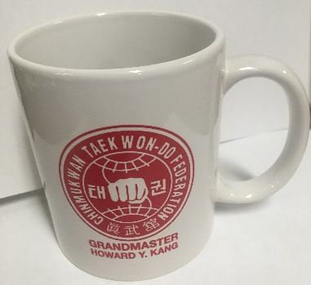

CTF Coffee Mug

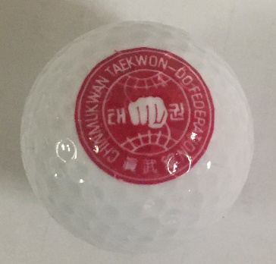

CTF Souvenir Golf Bar